Alexander Montgomery

26248115  CIS1703

Programming 2

Firstly there is the relationship between student and grade. I decided that the relationship would be a one to many due to a student having many grades but that one grade must have one student. Also, without student a grade will not exist so therefore composition.

As for student and course, I decided the relationship was aggregation as a student can leave the course and many students will be enrolled only into one course for example many students are enrolled in software engineering.

Finally, there is the relationship between Course and Grade. As course can have many grades for each module and one overall grade. Also without a course there will be no need for a grade therefore the relationship will be composition .

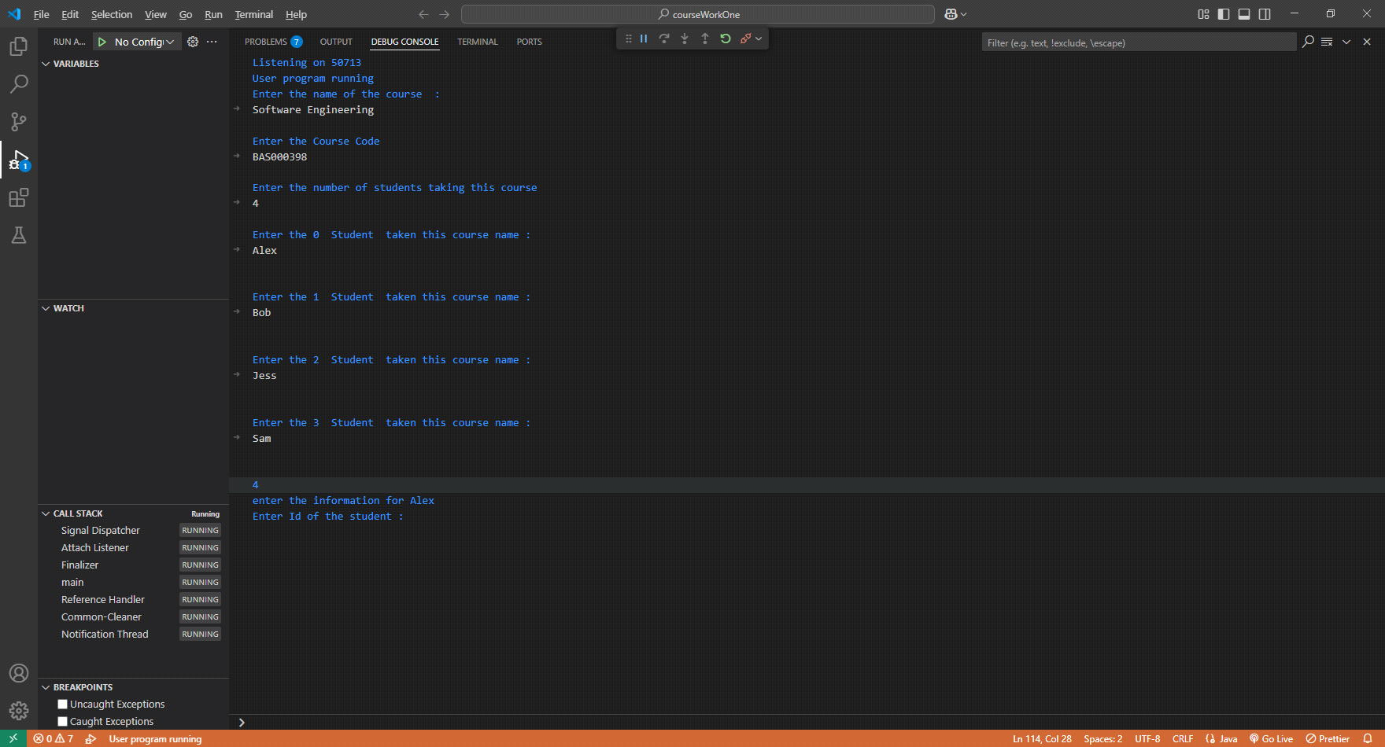

The program will start by asking for the user to imput the course information then this information will be assigned to an object called course through methods like setName and setId. They will be assigned a level of permission, for example course name is private and therefore can only be accessed within that class but courseCode is protected and will be inherited by the class grade. Then the program will ask for the number of students in the course and ask for their names to be inputted.



After course has been completed and all values assigned to that object, we moved onto assigning values to student. The values assigned to student are courses, ID and name and once confirmed that the courses chosen are accepted we move onto the object grade.

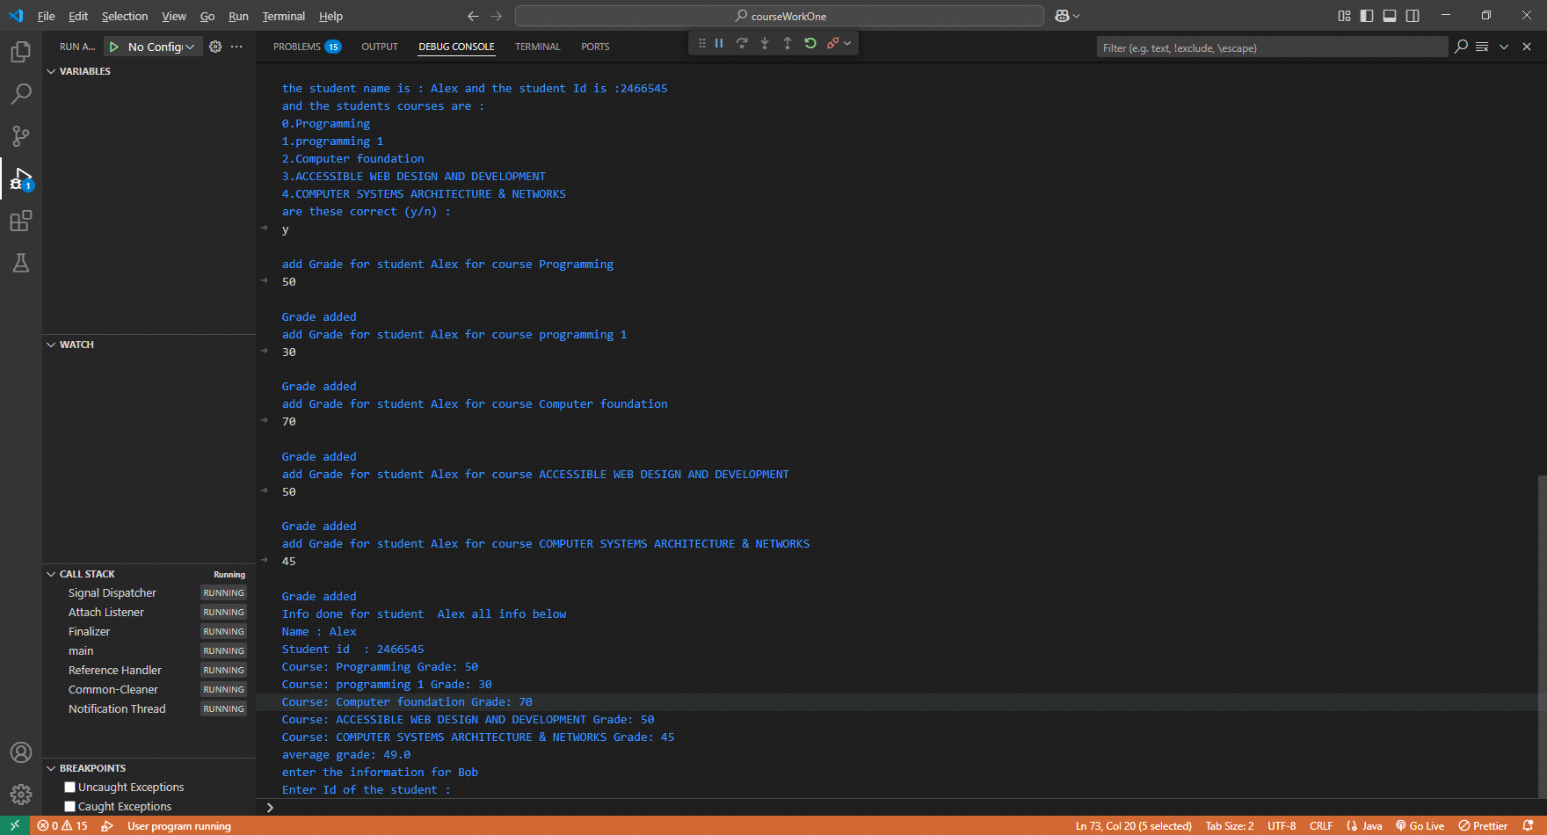

Then we move onto the grade class that accepts a grade for each course taken which will then output a average.